

**NATIONAL UNIVERSITY OF SCIENCES & TECHNOLOGY**

**Communication Systems (EE-351)**

Assignment 1 (CLO-1)

**Group Members**

|  |  |
| --- | --- |
| **Name** | **CMS ID** |
| Muhammad Ahmed Mohsin | 333060 |
| Muhammad Umer | 345834 |
| Syeda Fatima Zahra | 334379 |
| Danial Ahmad | 331388 |

**Submission Details**

|  |  |
| --- | --- |
| Submitted to: | Dr. Huma Ghafoor |
| Class: | BEE-12C |
| Semester: | 6th |

* **No late submissions will be accepted unless a prior approval from the instructor is obtained with extremely genuine reasons. The assignments submitted after the due date/time will be graded zero.**
* **University has zero tolerance for plagiarism and serious penalties apply.**
* **All assignments found mutually copied will be marked zero.**
* **Five marks are reserved for neat and clean work.**

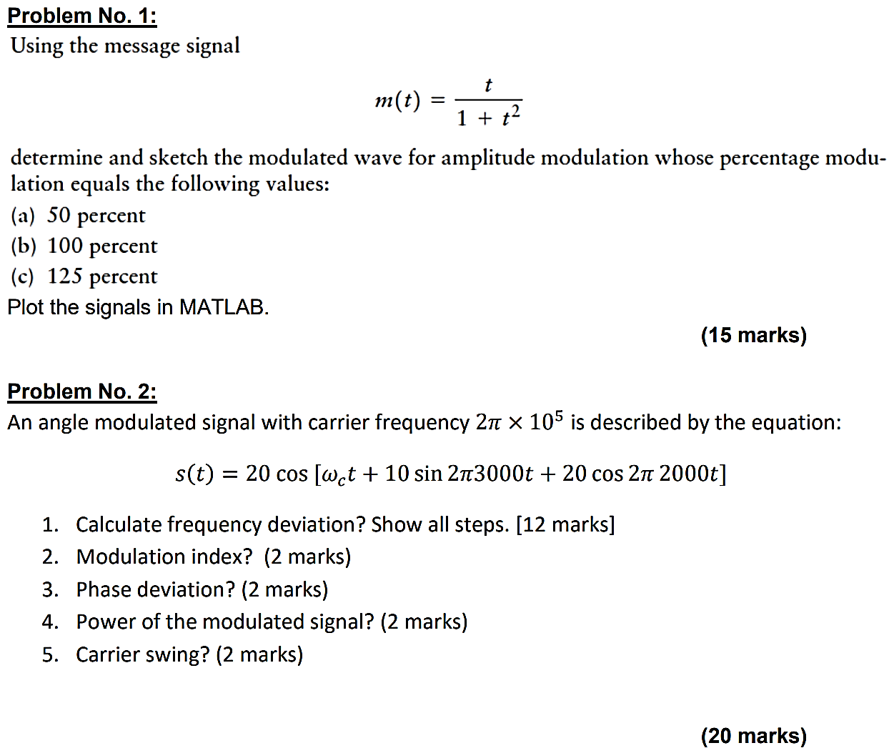

**Problem # 1**



**% Define parameters**

**fc = 20;**

**fs = 10 * fc;**

**T = 1 / fs;**

**t = 0:T:15;**

**m_t = t ./ (1 + t .^ 2);**

**c_t = cos(2 * pi * fc * t);**

**% Define sensitivity list**

**k_a_50 = 0.5;**

**k_a_100 = 1.0;**

**k_a_125 = 1.25;**

**% Define AM signals**

**s_t_50 = (1 + k_a_50 * m_t) .* c_t;**

**s_t_100 = (1 + k_a_100 * m_t) .* c_t;**

**s_t_125 = (1 + k_a_125 * m_t) .* c_t;**

**% Plot message signal and AM signals**

**figure**

**subplot(2, 1, 1)**

**plot(t, m_t)**

**title('Message signal')**

**xlabel('Time (s)')**

**ylabel('Amplitude')**

**subplot(2, 1, 2)**

**plot(t, s_t_50)**

**grid**

**title('AM signal: 50% modulation')**

**xlabel('Time (s)')**

**ylabel('Amplitude')**

**subplot(2, 1, 2)**

**plot(t, s_t_100)**

**title('AM signals: 100% modulation')**

**xlabel('Time (s)')**

**ylabel('Amplitude')**

**subplot(2, 1, 2)**

**plot(t, s_t_125)**

**grid**

**title('AM signal: 125% modulation')**

**xlabel('Time (s)')**

**ylabel('Amplitude')**

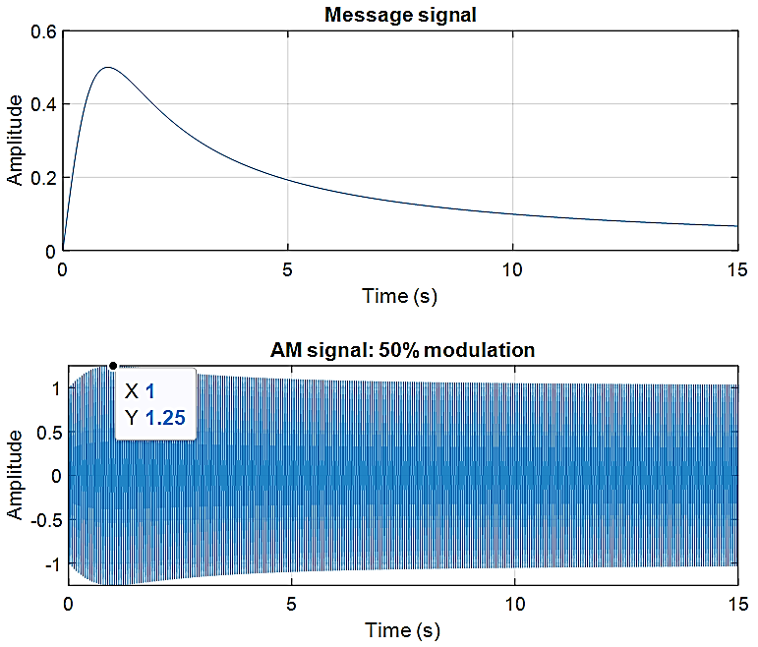

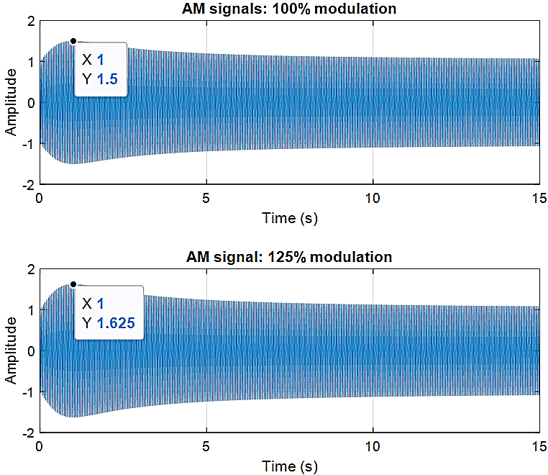

**Problem # 2**

Done by hand on appended pages.